**What is DevOps?**

DevOps is a set of practices that combines software development (Dev) and IT operations (Ops). The goal of DevOps is to shorten the development lifecycle and deliver high-quality software continuously. It emphasizes collaboration and communication between development and operations teams, automates the processes of software delivery and infrastructure changes, and aims to build a culture of shared responsibi`lity.

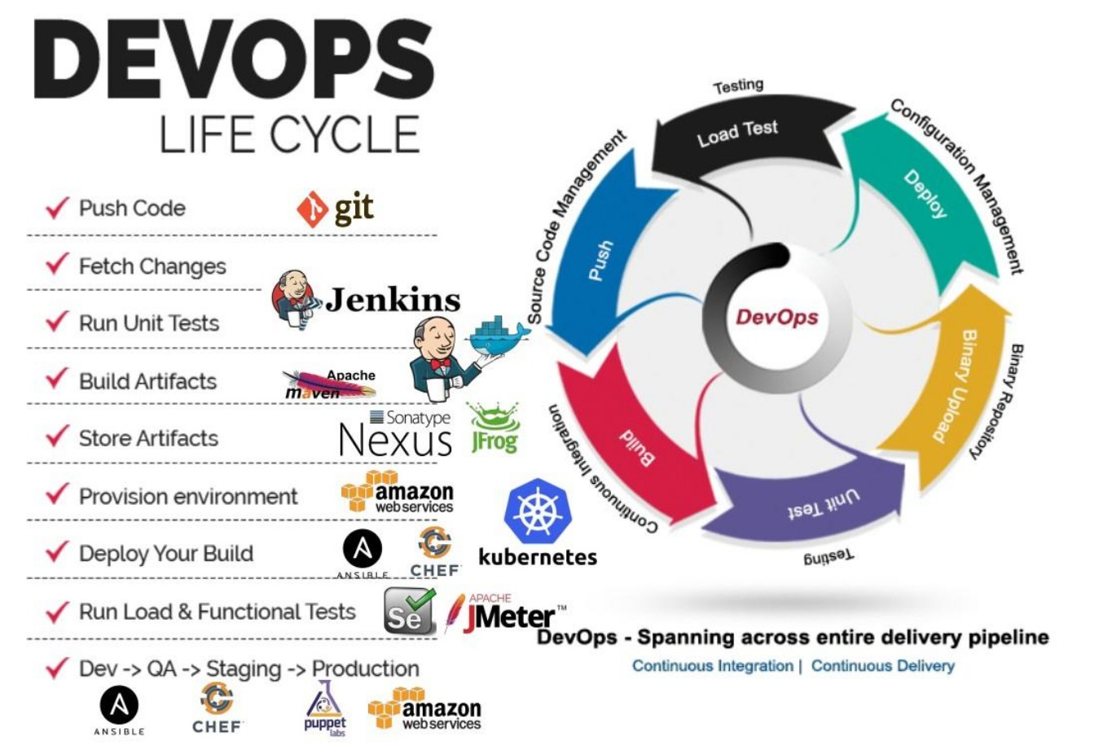

**Key Principles of DevOps:**

1. **Automation**: Automating repetitive tasks such as code integration, testing, deployment, and monitoring to improve efficiency and consistency.
2. **Continuous Integration/Continuous Deployment (CI/CD)**: Regularly integrating code changes into a shared repository and automating the deployment process to ensure rapid and reliable delivery of applications.
3. **Collaboration and Communication**: Breaking down silos between development and operations teams to foster a culture of transparency, shared goals, and mutual understanding.
4. **Infrastructure as Code (IaC)**: Managing and provisioning computing infrastructure through machine-readable definition files rather than physical hardware configuration or interactive configuration tools.
5. **Monitoring and Logging**: Continuously monitoring applications and infrastructure to detect issues, maintain performance, and ensure reliability.

**Responsibilities of DevOps Engineers:**

**1. Automation and Integration:**

* Automate the software development lifecycle, including tasks such as code integration, testing, and deployment.
* Implement and manage CI/CD pipelines to streamline the process of delivering code changes to production environments.

**2. Infrastructure Management:**

* Use Infrastructure as Code (IaC) tools (e.g., Terraform, Ansible) to provision, manage, and monitor infrastructure.
* Ensure scalability, security, and reliability of the infrastructure.

**3. Monitoring and Logging:**

* Set up monitoring tools (e.g., Prometheus, Grafana) to track the performance and health of applications and infrastructure.
* Implement logging solutions (e.g., ELK stack) to gather and analyze logs for troubleshooting and performance optimization.

**4. Collaboration and Communication:**

* Work closely with development, QA, and operations teams to ensure smooth delivery and deployment of software.
* Foster a culture of continuous improvement and shared responsibility for the quality and reliability of the software.

**5. Security and Compliance:**

* Implement security best practices in the CI/CD pipeline and infrastructure.
* Ensure compliance with industry standards and regulations (e.g., GDPR, HIPAA).

**6. Performance Optimization:**

* Analyze and optimize the performance of applications and infrastructure.
* Identify bottlenecks and implement solutions to improve efficiency and scalability.

**7. Incident Management and Troubleshooting:**

* Respond to and resolve incidents affecting the performance and availability of applications.
* Conduct root cause analysis and implement preventive measures to avoid future incidents.

**8. Documentation and Training:**

* Document processes, configurations, and procedures to ensure knowledge sharing and continuity.
* Provide training and support to development and operations teams on DevOps tools and practices.

**Tools Commonly Used in DevOps:**

* **Version Control**: Git, GitHub, GitLab
* **CI/CD**: Jenkins, Travis CI, CircleCI
* **Configuration Management**: Ansible, Puppet, Chef
* **Containerization**: Docker, Kubernetes
* **Monitoring and Logging**: Prometheus, Grafana, ELK stack
* **Cloud Providers**: AWS, Azure, Google Cloud Platform (GCP)

In summary, DevOps aims to create a seamless workflow between development and operations teams, leveraging automation, continuous integration, and continuous delivery to improve the speed, quality, and reliability of software delivery.

